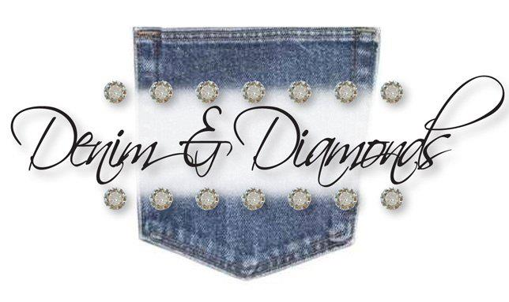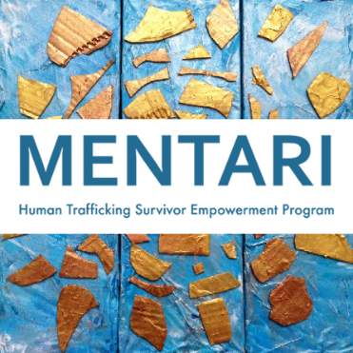
The Philanthropic Committee is pleased to announce that our Annual Philanthropic Luncheon will take place on Friday, November 11th, 2022 IN PERSON. The luncheon is open to guests and will be held at the Community House from 11:30 a.m. until 2:30 p.m. RSVP ASAP as seats will go fast!!

The main recipient of this year's charitable event will be Mentari Human Trafficking Survivor Empowerment Program. This organization has an amazing story, as do the people who created this charity.

Our theme for the luncheon will be "Denim & Diamonds." We encourage everyone to get into the spirit and wear your Fancy Jeans and Diamonds. There are four categories of support available:

DIAMOND LUNCHEON TICKET for $350 ($425 Value) limited availability and RSVP date of October 14th
This includes: one Luncheon Ticket PLUS
- 18 Denim Raffle Tickets
- 2 Rhinestone Raffle Tickets
- an invitation to a Cocktail Reception at the home of Jen Meier
on October 19th PRICELESS!!
Rhinestone Raffle Tickets - $100 apiece or 6 Tickets for $500
Denim Raffle Tickets - $10 apiece or 18 Tickets for $150
Luncheon only is $75 per person

RSVP by November 6th, to Angela Martin at 100-10 75th Avenue, Forest Hills, NY 11375
(Please make all checks payable to The Women's Club of Forest Hills.)

Return the slip below with your payment, together with any raffle tickets you purchase
_ _ _ _ _ _ _ _ _ _ _ _ _ _ _ _ _ _ _ _ _ _ _ _ _ _ _ _ _ _ _ _ _ _ _ _ __ _ _ _ _ _ _ _ _ _ _ _ _ _ _ _ _ _ _ _ _ _ _ _ _

________ Luncheon Tickets @ $75 per person $ ______________________
________ Denim Raffle Tickets @ $10 per ticket (18 Tickets for $150) $______________________
________ Rhinestone Raffle tickets @ $100 (6 for $500) $ ______________________
________ Diamond Donor @ $350 RSVP by October 14th $ ______________________
Additional Donation $_______________________

Total amount enclosed $ ______________________

Name: __________________________________________ Phone #_______________________________
Please list your seating preferences on the back, plus any guests’ names

